A User’s Guide to Roll1903.dbf

This database is Montréal, l’avenir du passé’s (MAP) digital edition of a Montreal City Council publication that listed all properties in the city and provided details on their owners. This was the one and only time the city published such a list and at 1,340 pages one can understand why.

This publication was a reference work designed to stimulate speculation in urban real estate. Its 32,148 entries were organized by ward and then by address. If you were interested in a particular property, it was easy enough to find. If you were interested in anything else, it was difficult if not impossible to find, let alone understand the myriad patterns made by these hundreds of thousands of pieces of information. This database is qualitatively different. All of the information the publication contains can now be easily queried and analyzed. The research possibilities are endless, but they are not without their own limitations. This user’s guide introduces you to the specificity of each variable within the database. Posing historically-informed questions of this database starts with knowing how and why the publication was organized the way it was.

Having discovered a copy in McGill Libraries, the MAP team identified it for conservation in 2000. McGill Rare Books did the scanning and optical character recognition. Like this database, the publication was a collectively authored document − created initially by a team of city appraisers, whose practices evolved over time and place. In the publication, each entry extends across a double page, employs elaborate three-story headers for the columns and an unusual type face with exaggerated ascenders and descenders. To obtain sufficient resolution with the scanner then available, the lefthand and righthand pages were scanned as separate images and each page was exported from the OCR program as a separate Excel file. Patricia Thornton re-stitched these spreadsheets. Proofing was primarily undertaken by Robert Sweeny, who transformed the resultant combined spreadsheets into a database and then into a historical-GIS, now available as QGIS applications from our website.

This database reproduces the publication as accurately as possible. Errors were introduced by the optical character recognition process and in our successive conversions between software. In our proofing, we have given priority to names, addresses, and property values. Each entry contains the thirteen columns of the publication, the entry’s page number and ward, as well as four additional fields not found in the original : Remarks, Lots03id, Ownerid and RowNumber. Remarks flags typographical errors found in the original as well as noting combined entries, where the information was spread across several adjacent entries. The Lots03id links the entry to a specific lot in MAP’s historical GIS applications based on this database. These applications contain a wide variety of additional analytical fields and so for many questions you will find it easier to work with them rather than this database of record. The Ownerid allows you to group all the entries belonging to the same person, firm, or institution. RowNumber is a unique identifier for that entry and indicates the order in which the entry was processed.

The text of the original document generated eight numeric fields : Page, Rent, UnitPrice, SquareFeet, LandValue, BldgValue, Exempt, and TotalValue and seven character fields : Ward, Address, Owner, SchoolTax, Cadastre, SbDivision, and Dimensions These notes explain each in the order they appear in the original publication.

Page refers to where you can find the entry in the publication. It does not allow you to reconstruct the original order on the page. To do this you have two options; index on Lots03id and then on Page; or use RowNumber which does present the page contents in order, but it starts at page 50, and only lists the first 49 pages sequentially after RowNumber 1086.

The city had 18 different wards and as is clearly visible on the map there were five quite distinct ranges of average prices : the recently absorbed suburbs of St Gabriel, St Jean Baptiste, Duvernay, St Denis and Hochelaga; the primarily residential wards east of St Laurent Blvd; the older mixed use wards of St Jacques, St Laurent, St Joseph and Ste Anne; the affluent wards above the escarpment in the west and the city centre.
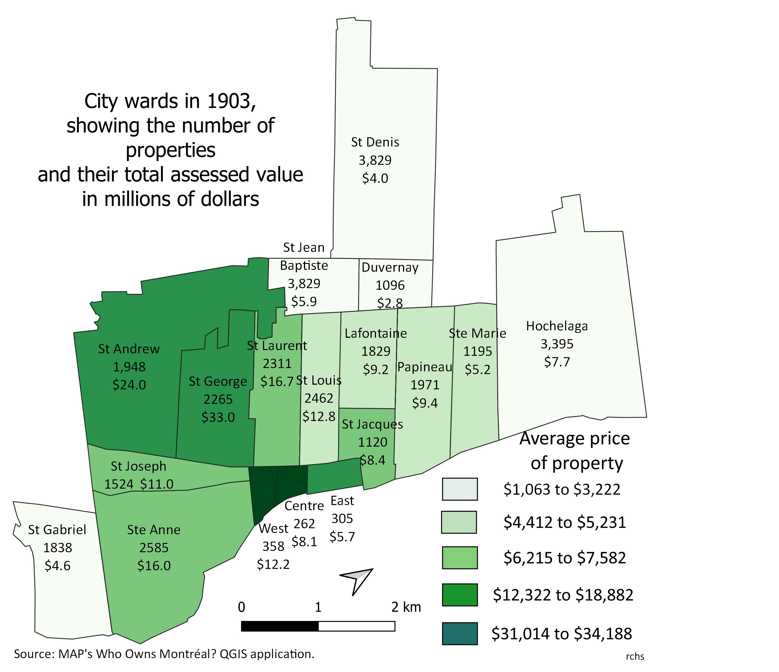
The three wards of the old city West, Centre and East were the central business district. These wards had the highest average property values in the city. Historically a manufacturing and artisanal centre, the West ward was by 1903 home to the financial district, principally along Greater St James and Notre Dame streets. In its southern reaches, including Pointe à Callière, were concentrated the businesses associated with the port, Canada’s largest. Centre ward was home to Notre Dame and its affiliated seminary of the gentlemen of Saint Sulpice, the former seigneurs of the island and still among the city’s largest property owners. Two female orders, the Sisters of St Joseph and the Congregation of Notre Dame, were also large property owners, although the former had already redeveloped as commercial buildings its large property which had once housed the Hôtel Dieu hospital. Centre ward was also home to the courts and legal professions. East ward, in the process of being transformed by the opening of the Viger terminus of the Canadian Pacific Railway, was the only part of the old city that still had a residential population. It was home to both City Hall and Marché Bonsecours, the largest food market in the country.

St Joseph ward, to the west of the old city, had been an artisanal centre dating from the late 18th century and so had the smallest lots in the southwest of the city. Ste Anne, the primary site of Canada’s industrial revolution, was first developed as a manufacturing area adjacent to the Lachine Canal in the 1820s and 1830s and so had much larger lots, as well as a clearly discernible ‘modern,’ grid street pattern. Its western reaches was home to the largest concentration of Irish Catholics in the city, while the southern portion, Pointe St Charles, below the Lachine Canal, had since mid-century been home to the Grand Trunk Railway yards, where a significant number of skilled Protestant workmen found employment, many of whom continued to live in the neighbourhood in 1903.

The wealthiest residential area of the city, the old St Antoine ward above the escarpment in the west, had by 1903 been divided into two wards : St George and St Andrew. Since first developed in the 1840s, this area was overwhelmingly Protestant and English-speaking. The legendary ‘Golden Square Mile’ was located primarily in the northern and central parts of St George ward, to the west of McGill’s campus. While over the previous two decades a new shopping district had developed along St Catherine street, from Phillips Square west to Atwater.

St Laurent and St Louis were central wards and although they went as far north as Duluth, by 1903 there had been relatively little development above Sherbrooke Street. Divided by Boulevard St Laurent, The three wards of the old city West, Centre and East were the central business district. These wards had the highest average property values in the city. Historically a manufacturing and artisanal centre, the West ward was by 1903 home to the financial district, principally along Greater St James and Notre Dame streets. In its southern reaches, including Pointe à Callière, were concentrated the businesses associated with the port, Canada’s largest. Centre ward was home to Notre Dame and its affiliated seminary of the gentlemen of Saint Sulpice, the former seigneurs of the island and still among the city’s largest property owners. Two female orders, the Sisters of St Joseph and the Congregation of Notre Dame, were also large property owners, although the former had already redeveloped as commercial buildings its large property which had once housed the Hôtel Dieu hospital. Centre ward was also home to the courts and legal professions. East ward, in the process of being transformed by the opening of the Viger terminus of the Canadian Pacific Railway, was the only part of the old city that still had a residential population. It was home to both City Hall and Marché Bonsecours, the largest food market in the country.

St Joseph ward, to the west of the old city, had been an artisanal centre dating from the late 18th century and so had the smallest lots in the southwest of the city. Ste Anne, the primary site of Canada’s industrial revolution, was first developed as a manufacturing area adjacent to the Lachine Canal in the 1820s and 1830s and so had much larger lots, as well as a clearly discernible ‘modern,’ grid street pattern. It’s western reaches were home to the largest concentration of Irish Catholics in the city. It’s southern portion, Pointe St Charles, below the Lachine Canal, had since mid-century been home to the Grand Trunk Railway yards, where a significant number of skilled Protestant workmen found employment, many of whom continued to live in the neighbourhood in 1903.

The wealthiest residential area of the city, the old St Antoine ward above the escarpment in the west, had by 1903 been divided into two wards : St George and St Andrew. Since first developed in the 1840s, this area was overwhelmingly Protestant and English-speaking. The legendary ‘Golden Square Mile’ was located primarily in the northern and central parts of St George ward, to the west of McGill’s campus. While over the previous two decades a new shopping district had developed along St Catherine street, from Phillips Square west to Atwater.

St Laurent and St Louis were central wards and although they went as far north as Duluth, by 1903 there had been relatively little development above Sherbrooke Street. Divided by Boulevard St Laurent,or the ‘Main’, these two wards were historically quite distinct, St Laurent, west of the Main, was considerably more affluent ward than St Louis and had been home to both substantial artisanal and manufacturing facilities as well as bourgeois streets, such as St Urbain and Sherbrooke. By contrast, St Louis was home to the city’s largest concentration of day labourers from early on in the nineteenth century.

With the pogroms in Roumania in the 1880s and then throughout the Russian empire in the 1890s, thousands of Jewish families immigrated to Canada. Montréal’s first Jewish ghetto developed in St Louis ward between Ontario and St Catherine streets. There was also a considerable number of Italian families living in the ward. While the southern reaches of St Laurent was home to Montreal’s Chinatown, almost two hundred Chinese household-based laundries were very widely distributed throughout the city. These new immigrants created Canada’s first multi-cultural neighbourhoods, buffering the highly segregated English-speaking west end from the overwhelmingly French Canadian east end of the city. Very few of any of these immigrant households, however, owned their own homes and so it is largely their landlords and landladies who are recorded in this database.

Running north from the East ward, traversing both St Jacques and Lafontaine wards, was the bourgeois St Denis/St Hubert corridor. Home to Laval University’s Montréal campus, this affluent French- Canadian neighbourhood had its own shopping district along eastern rue Ste Catherine. In Papineau ward, east of Côte de la Visitation, was the greatest concentration of duplexes and triplexes in the city. In Ste Marie there were also many densely populated lots, but mixed in among workshops, manufacturies and factories. These two wards had the highest population densities in the city.

Five of the wards were recently absorbed suburbs : St Gabriel, St Jean Baptiste, Duvernay, St Denis and Hochelaga. As is clearly visible on the map, they occupied the lowest rung in the city’s hierarchy of wards. Although all were primarily French Canadian, each of these areas of the city had a quite different history and built environment. St Gabriel, south of the Lachine Canal and west of Pointe St Charles, was the last ward to get proper water and sewage. It was also the ward that boasted the largest proportion, 85%, of local landlords. St Jean Baptiste and Duvernay developed as industrial villages in the 1870s, with St Jean Baptiste having the smallest size lots of the 19th century city. In 1903, large swaths of both St Denis and Hochelaga still lay vacant, owned by two land companies: the St Denis Land Company and the Montreal Land and Improvement Company. Between Hochelaga and the city proper lay the first CPR yards and as the publication was being prepared, the CPR was building the Angus Shops to the north. Hochelaga did have an industrial history of its own. It was home to the largest of the country’s cotton mills and, as this might suggest, its own concentrations of duplexes and triplexes.

Address records only what the publication provided. Vacant lots were not assigned a street number. Numerous built lots containing industrial or institutional properties also were not assigned any street numbers. Numbering of streets started at their eastern or southern end. Even numbers ran along the western or southern side of the street, with odd numbers along the eastern or northern sides. There was not yet any system which allowed you to know approximately where an address was located simply by its number. This would only come with a complete redesign of the system, which took twenty years to complete, starting in 1906 with dividing all streets running parallel to the river into east and west as they crossed the ‘Main’.

It was not at all uncommon for properties to have residential units facing the street and others in the rear of the property, identified with the letter ‘r’. As properties were redeveloped additional units were built and so halves, indicated by ‘h’ in the address, or a combination of letters were frequently introduced. From the range of house numbers we cannot establish how many units, residential or commercial, were on any given property. For example, an entry that reads 86a – 88b had at least three units, (86a, 88a & 88b) but it might have had four (88) or five (86b).

The Address field has its greater use as a way of linking to others sources. Lovell’s street directory for 1903 is available on online from the BAnQ. While MAP has developed an application that links households from the 1901 census to a historical-GIS of this database. We recommend you explore these resources if you are interested in finding out more about who lived at particular addresses.

The Owner field has been the subject of extensive proof-reading, but it undoubtedly still contains some errors. We have respected the spelling and abbreviations used in the publication. Abbreviations commonly used include: est/suc for estate or succession; wif/épse for wife or épouse; wid/vve for widow or veuve; jr/sr for Junior or Senior – the French langage equivalents of fils (son) and père (father) were not abbreviated; Hon/hon for Honourable or honorable and Co./Cie for company or compagnie. Both people and firms or institutions could have wide variations in their nomenclature, so to ensure that you have all the properties of a particular owner use the unique identifier Ownerid.

Women owned more than a fifth of all taxable properties in the city and more than a quarter of all those belonging to people, i.e. not owned by firms or institutions. Quebec’s Civil Code accorded differing civil rights to women based on their marital status. Single women, above the age of majority of 21, and widowed women had more rights than married women. Widows and single women had the right to vote in municipal and school board elections if they met the property qualifications. A married women was denied the franchise, but if her property holdings were substantial enough to meet the qualifications they enfranchised her husband, and any male offspring above the age of 21 still living with her.

The default marriage regime was a community of property with the husband ‘head and master’ of the community. Revenues from a property owned by the wife as her own, or propre, considered outside of the community still went to the husband. It was not uncommon by 1903 for wealthier couples prior to their marriage to opt out of community and establish a separation of property between bride and groom.

Legally, culturally and politically this discriminatory regime mattered and the city went to great lengths to accurately record the marital status of female proprietors. So we have the maiden name of married and widowed women, as well as the names of their husbands living or dead. The publication even specified if an estate was for a woman who had been widowed or was still married at the time of her death. Again, MAP’s QGIS applications based on this database allow you to explore in considerable detail this gendered cleavage in Montréal society.

Unfortunately, there is no easy way of establishing what type of marital regime governed a married woman listed in the database. Was it a community of property, or some type of separation of property? BANQ-Montréal lists 123 notaries public practising in the city in 1903 and one has to consult their repertoires and/or indexes to locate marriage contracts of couples appearing in this database. Even then, if the marriage was celebrated outside the judicial district of Montréal, and the custom was to celebrate it in the parish of the bride, then the contract would in all likelihood have been signed before a notary practising in that parish, as these contracts had to be completed before the marriage took place.

Quebec had a confessional school system, with separate Catholic and Protestant, or ‘Dissentient’, school boards. These boards were funded by a SchoolTax levied on property. The publication indicated which board should receive that owner’s taxes: C for Catholic; P for Protestant; N for neutral’ Ex for exempt and JP for Jewish households whose taxes went to the Protestant board. Neutral tax payers were companies and institutions whose taxes were shared by the boards proportionally on the basis of student enrolment. Charitable organisations were generally exempt and so, ironically, many important Catholic and Protestant institutions in the city paid no taxes to support their community’s schooling.

The SchoolTax was a flat tax: 25¢ per $100 of assessed value and so generated substantive inequality. The 3,408 people opting to pay to the Protestant school board owned considerably more, on average, than the 8,235 people choosing the Catholic board, $6,706 vs $3,760. As a result, this tax generated $146,847 for the Protestant board, but only $178,064 for the Catholic board, in a city where Protestants were just a fifth of the population. While the $62,380 from the 233 ‘neutral’ owners was distributed on the basis of enrolment, it was woefully inadequate to compensate for this structural inequity.

Rent is the annual rent as assessed by the city for the entire property, which could contain a number of dwellings or commercial premises. No rent was assessed on vacant lots. Please note the rents were assessed for tax purposes, so owner-occupied properties were assessed a rent even though they did not pay one. We do not know, however, based on this publication, how many housing or commercial units each entry represented. David Hanna and Robert Lewis, working with Sherry Olson in the 1980s and 1990s, found that the city’s assessments of rent reflected quite accurately the size of individual premises, with residential units being assessed at $20 per room a year. As rental values were rarely reported on municipal taxrolls, these published rents offer clues to both the appraisal process and the socio-economic characteristics of particular streetscapes and neighbourhoods.

Cadastre and Sbdivision are two related variables on the roll. A cadastral system is a form of land registry and Montréal’s first cadastre dates from the 1870s when it replaced the seigneurial system of terriers. Lots subsequently sub-divided were treated as part of a cadastre, noted by the letter ‘p’, and not infrequently included detailed sub-division numbers created by the real estate developer. By 1903, accurate identification of the exact placement of a particular lot would have often relied on these overlapping public and private systems of identification. Using the sub-division information you can reconstruct the strategies and scale of differing real estate developers over the previous forty years.

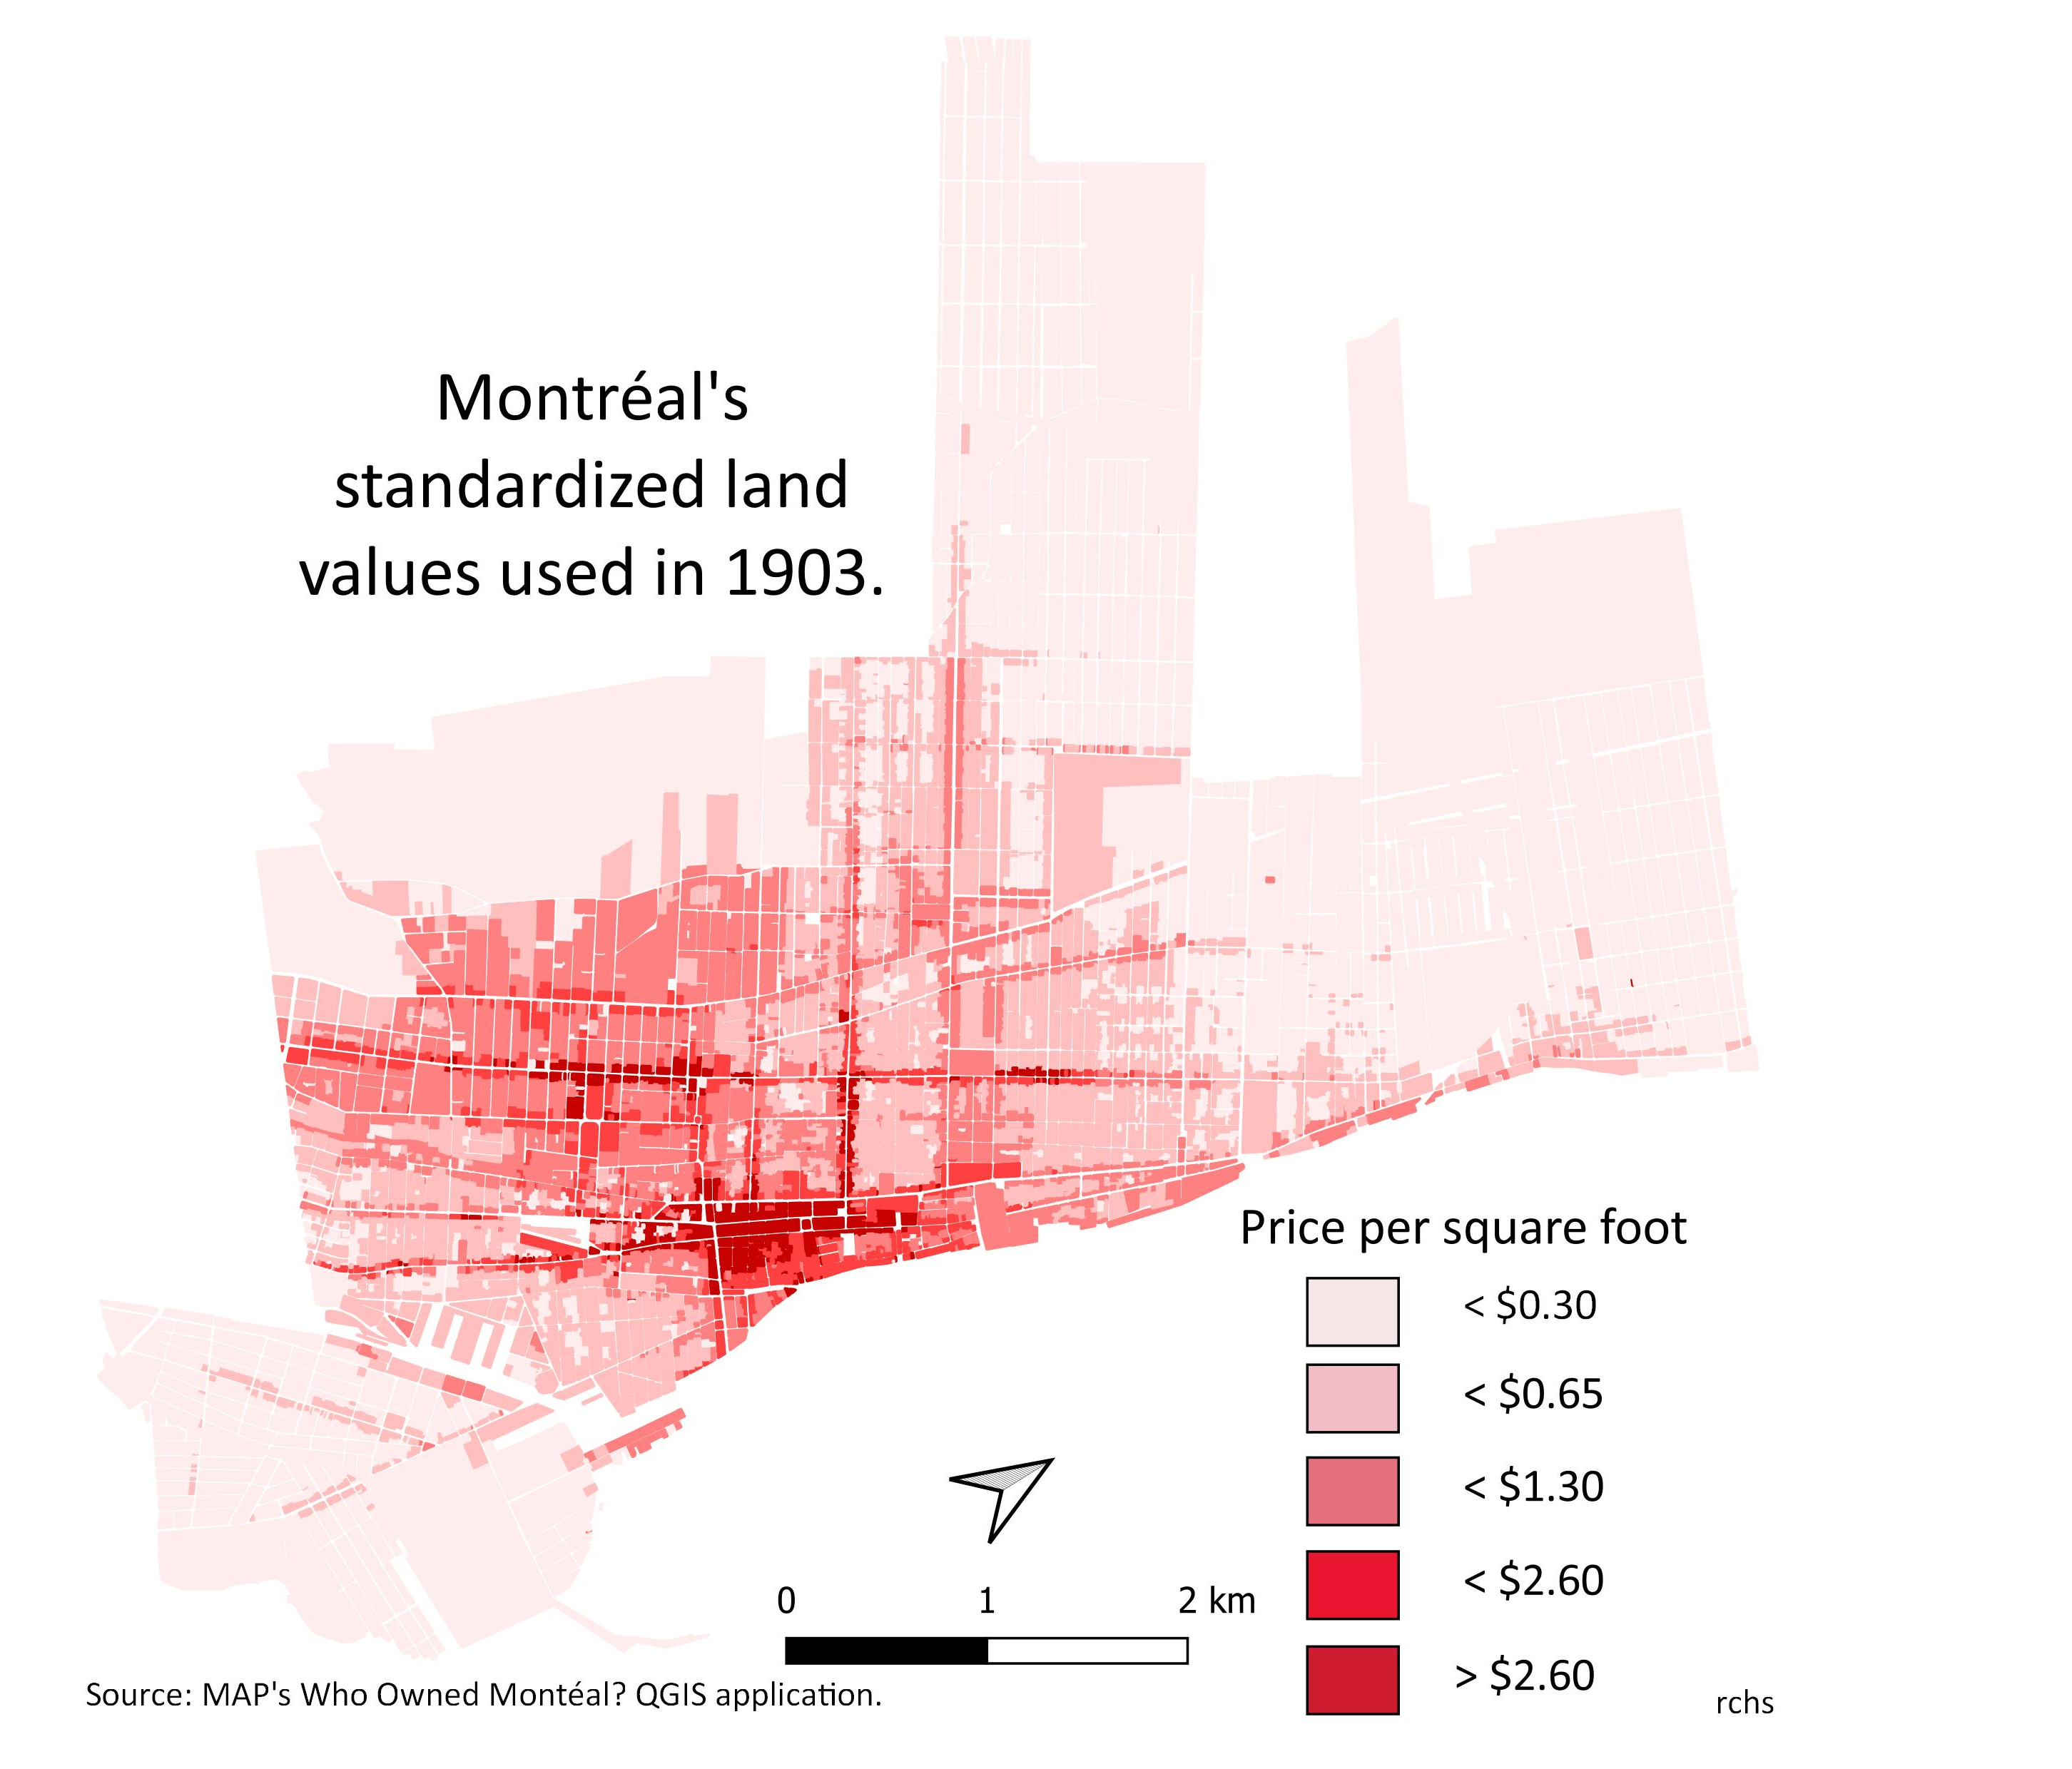
The UnitPrice is the price per square foot that the city appraisers assigned the land. Interestingly, although this form of standardized pricing was not unusual in North America, this publication is the first time it appears in a Montréal city document. It was not yet part of the city’s evaluation rolls, which are available online here. Our analysis of this new variable indicates there were 126 different prices used, ranging from less than 10¢ a foot in St Denis ward, to over $17 a foot on Greater St James Street. These nuanced variations across the city’s landscape offer important evidence for detailed examinations of particular neighbourhoods. Our mapping of just the major price bands clearly highlights the financial district in the West ward, the two key retail districts along Ste Catherine, the importance of the lower Main and the relative wealth along Sherbrooke and parts of Dorchester. It also hints at the close attention city appraiser paid to minor commercial streets. A finer analysis would reveal the importance accorded to corner lots.

SquareFeet records the area of the lot when it was given. It does not always concord with the Dimensions provided because many lots were irregular in shape. The dimensions are given in feet; there are 30.48 cm in a foot.

The city only introduced a LandValue separate from the total evaluation in 1899. By 1903, it was always given and as a property normally had only one UnitPrice assigned to it, one can use these two variables to establish the area of the lot when missing. Care must be taken, however, because combined lots, that is properties where the details were spread over multiple entries, often had differing unit prices. These properties are identified in the Remarks field.

Like land values, the BldgValue was introduced in 1899. By 1903, it was given for almost all built properties, even where no Rent was assessed. An important component of building values was the construction material used. In the city centre by zoning regulations, and in the more affluent wards by custom, brick or stone was required. Elsewhere, buildings were normally built of thick wooden planks clad with a facade of brick; front porches, back sheds and fire escapes were normally of wood. It is only in the newly absorbed suburban wards that one still found rows of entirely wooden structures. The publication provided no information on the type of building materials used, although MAP’s QGIS applications based on the Goad atlases of 1880 and 1912 do allow for a detailed overview of the evolution in building materials across the city. In most wards, including the old city centre, many extant buildings date from before 1903 and so one can ground truth these evaluations.

Exempt properties were either owned by the government, or by charitable, principally religious, organisations. There were, however, properties owned by individuals which were exempt from taxation because they were used for a charitable purpose. For example, Royal Victoria College, the women’s college associated with McGill University and assessed at $170,000, was exempt although it was owned not by McGill, but by Donald Smith, Lord Strathcona and Mount Royal. It was not uncommon for only part of a property to be considered exempt.

The 255 properties in whole or part exempt from taxation were worth $41.3 million, a fifth of the total assessed value of the city. Exempt properties were to be found in every city ward. The 74 exempt properties in St Andrew and St George wards totaled $17.5 million. The only wards where exempt properties were worth less than a tenth of the taxable property were West ward, home to the financial district and port, and the heavily industrialized St Joseph and Ste Anne wards. The distribution and relative importance of exempt properties in the differing wards of the city is a highly revealing window onto the values and culture of this time and place.

This publication was based on the tax evaluation roll of 1903, although it included any changes in assessments stemming from appeals. The city’s understandable interest in taxable properties was highlighted by the fact that the exempt value of any appraised property was excluded from the TotalValue column. The property tax was a regressive flat tax of one percent. The burden of this tax on the 2,107 owners of built properties worth less than $2,000, it would have been felt much less by the 1,242 people who possessed portfolios worth in excess of $20,000.

The spatial distribution of property ownership favoured the local. This becomes much clearer when the 32,148 properties of this database are consolidated into a database with an entry for each proprietor. It is highly recommended that you analyse not just TotalValue, but all this database’s fields informed by our Owners03.dbf, which provides the totals for rent, land, buildings, exempt properties, total values, number of units, number of properties, number of wards and gender for each of the 11,258 owners in the city. We have prepared a user’s guide similar to this one for the Owners03 database and it is best to read both before starting to work on either these databases or the QGIS applications.

In addition to Roll1903.dbf database, we have released three databases: the owners database, Owners03.dbf; a database of all household heads in the 1901 census, Cpoint01.dbf; and a database of the consolidated lots Lots03.dbf. All four databases can easily be linked by common fields and the resultant relational database is the most complete historical data source currently available for any North American city. Despite the exceptional richness of these related databases, we strongly recommend downloading the QGIS applications from our website. The open source GIS software QGIS offers a visual and spatial component to the analysis that is exceptionally enriching. MAP has created QGIS applications for 1825, 1846, 1881 and a soon-to-be released 1912, so one can easily place these turn-of-the-century materials into their historical and spatial context.

. Valuation and Assessment Roll of Immoveables of the City of Montreal, 1903-04. Montréal: Perrault Printing Company, 1904
. The cardinal points of Montrealers do not match those of the compass. We think of the St Lawrence as running west to east, so north is away from the river and south is towards the river. The orientation of the maps and the language in this guide respect this local, century-old, perception of space.

